**Class Exercise – Practice 2**

**MIS 64038**

1. Plot the following using ggplot()

ggplot(cars, aes(x=displ, y = cty, colour = class)) + geom_point()

1. Plot the following (adding one more dimension):

ggplot(cars, aes(x=displ, y = hwy, shape = drv)) +

geom_point(colour = "orange")

1. Plot the following graph (adding more dimensions)

ggplot(cars, aes(x=displ, y = cty, size = drv)) +

geom_point(colour="green")

1. Plot the following graph:

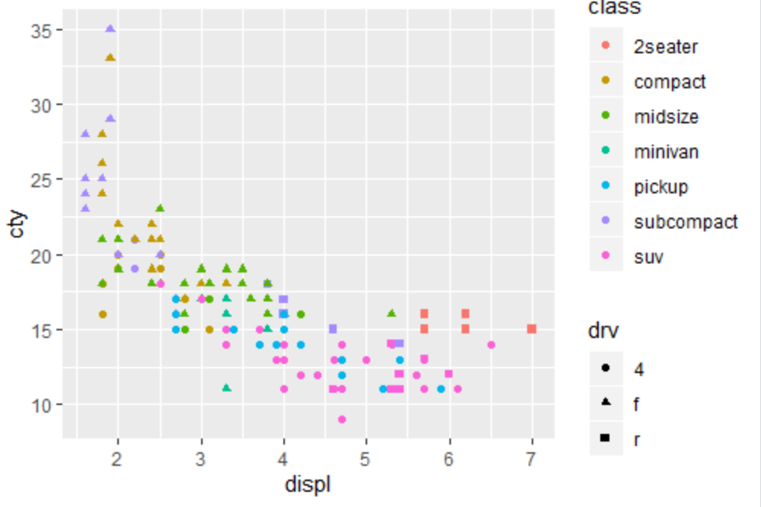

1. Plot the following graph:

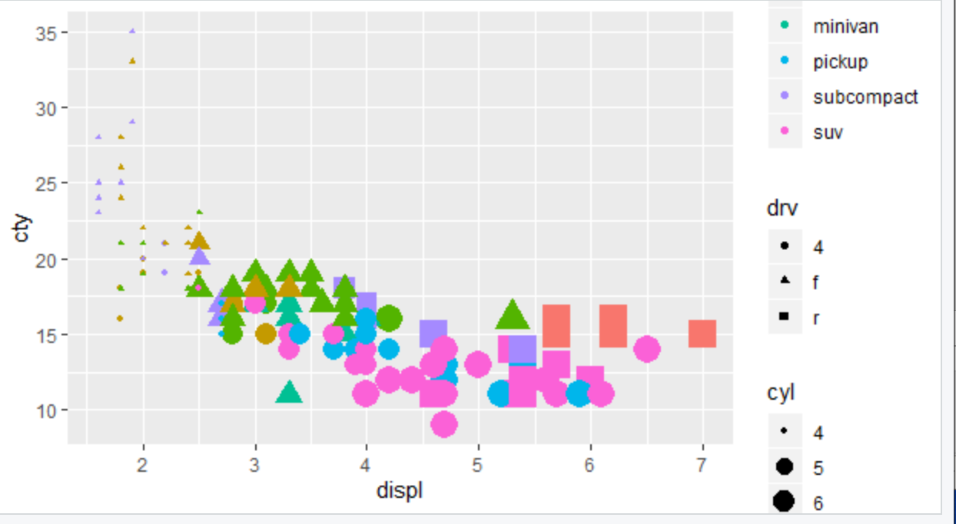

1. How is drive train related to fuel economy? Plot and show
2. How is drive train related to engine size and class? Plot and show
3. What happens if you map trans variable to shape? Why?